**API Detail for start Job in Orchestrator**

End point for UiPath Swagger (Below mentioned all end points are referred from below swagger URL):

https://platform.uipath.com/endtofizrisq/EndToEndDefault/swagger/ui/index

**How to Get Client ID and Refresh token from Orchestrator:**

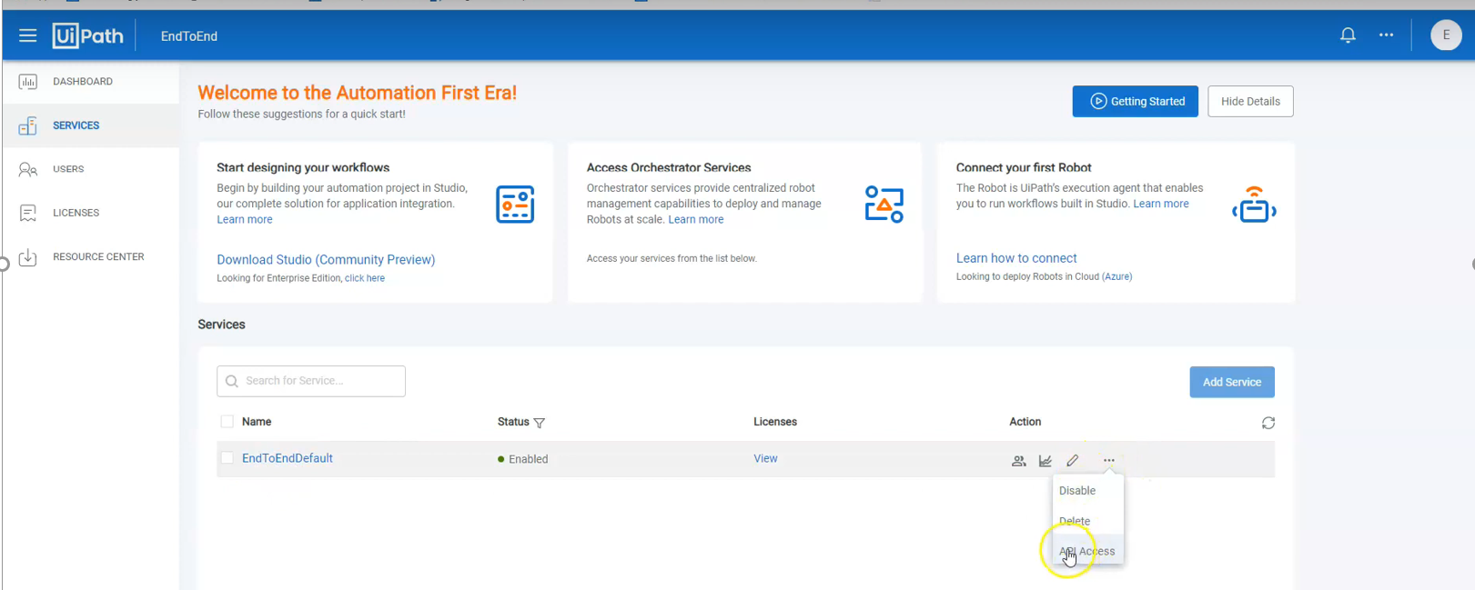

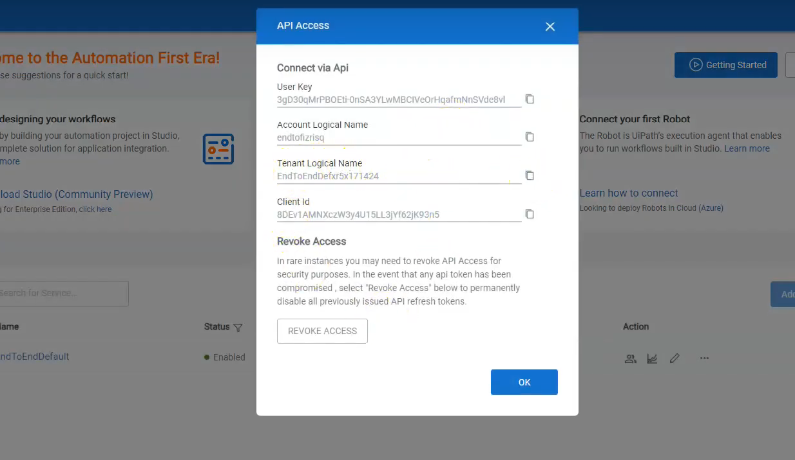

**Perform below four steps in Postman tool:**

**1.Authendication (Only for Cloud Orchestrator-community edition)**

End Point(Post Request) -

https://account.uipath.com/oauth/token

Headers-

X-UIPATH-TenantName - Value(Tenant Logical Name from your Orchestrator)

Body: Raw, Jason

{

"grant_type" : "refresh_token",

"client_id" : "<<Client id from Orchestrator>>",

"refresh_token" : "<<User key from Orchestrator>>"

}

**Output-**

access_token(copy it from response, Below one is sample access_token and it will get expire in half an hour)-eyJhbGciOiJSUzI1NiIsInR5cCI6IkpXVCIsImtpZCI6IlJUTkVOMEl5T1RWQk1UZEVRVEEzUlRZNE16UkJPVU00UVRRM016TXlSalUzUmpnMk4wSTBPQSJ9..En_GnVo1p8FAyzV6mgZKI8gUIpX9Jqh8AOubxU8CSUUXbNFzIWquQNq7DaAm_cR7e2C5Gh0zkCgDQ-khG7iJYdjzmHMOvjbZxlBaxoJoOXfZ87Xc2zs29SWuaNYKe6kXyouw-Pd8zG2gWIecBpdGQ1v_GXHeV0xDw6xZxBaRvxVzfW1KopaUiIVKP0Hqjb658oWFpQd4piS6651vwvSyA6a2NCgN2Ia0kIn_thSE_STHjn9uwB0y40hFSAgn08JesWn_odinpX3ZnN_PHpFVsDq3JIlQ04IlpFwOR5obCjIb6SunD8nijltxOMMtfesl6PSAIqxacR_H1U7nE1dokg

**Sample Screenshot for Step 1:Request for Access Token**

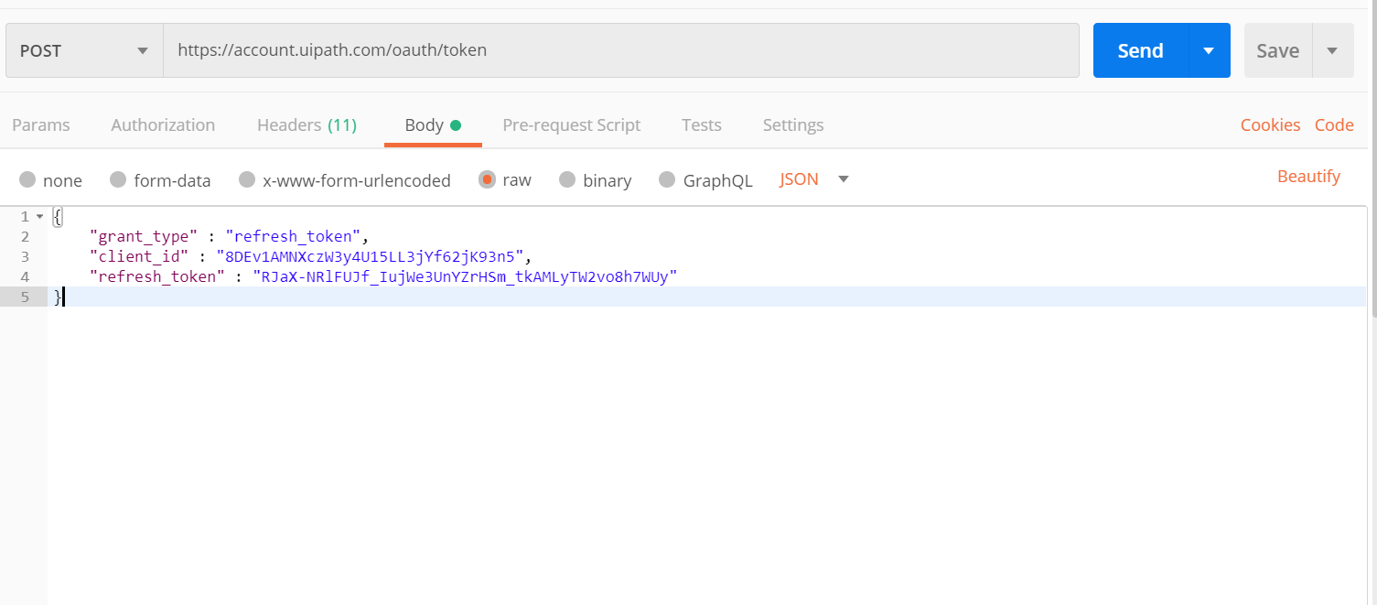

Response with Access_token:

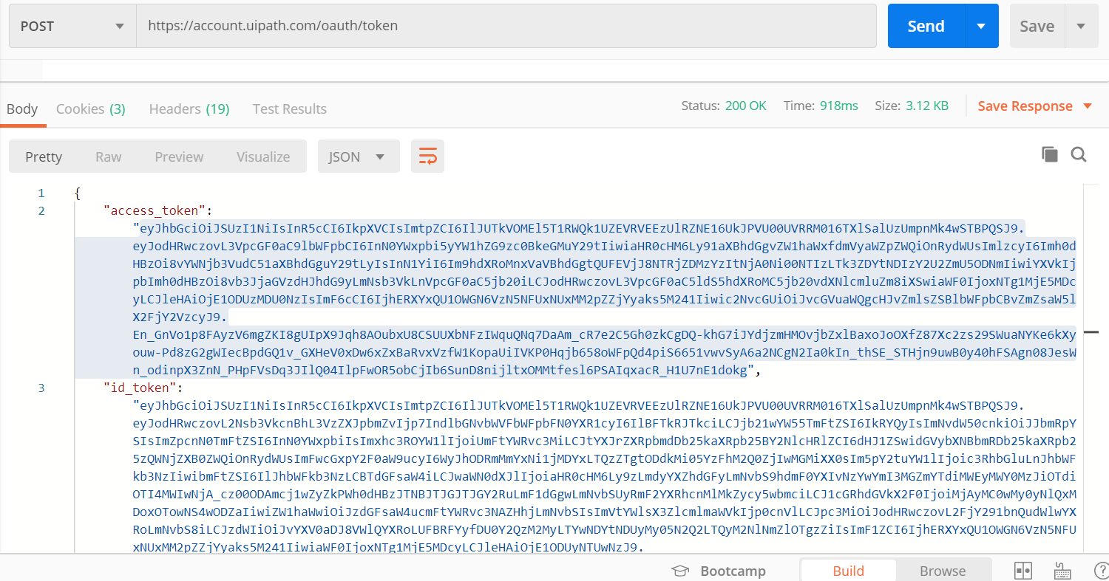

**2.Get Release Key**

End Point(Get Request)-

https://platform.uipath.com/endtofizrisq/EndToEndDefxr5x171424/odata/Releases

Authorization Tab: No Auth

Headers-

X-UIPATH-TenantName - Value(Tenant Logical Name from your Orchestrator)

Authorization - Bearer <<access_token noted in the last step>>

**Output-**

Robot ID(Copy it from Repponse)-

a38ac2b9-66d2-4724-930c-efad19c2d889

**Sample Screenshot for Step 2: Request for Release Key**

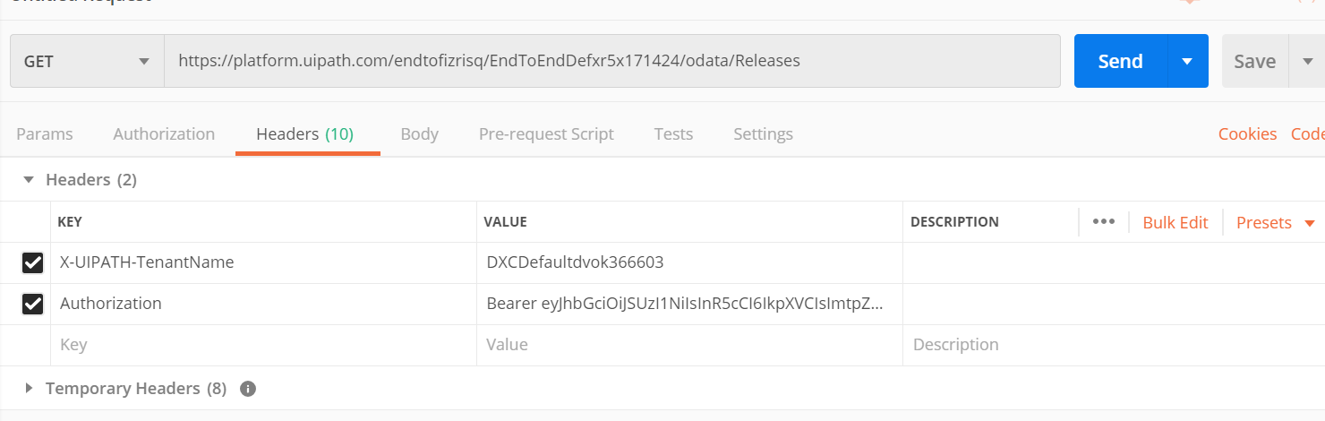

Response:

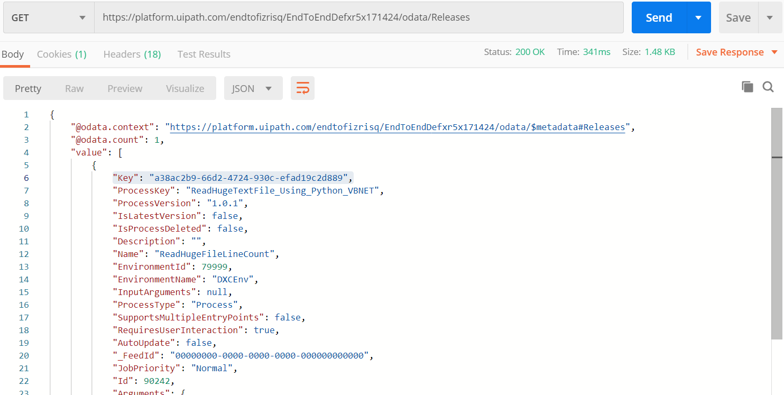

**3.Get Robot ID**

End Point(Get Request)-

https://platform.uipath.com/endtofizrisq/EndToEndDefxr5x171424/odata/Robots

Authorization Tab: No Auth

Headers-

X-UIPATH-TenantName - Value(Tenant Logical Name from your Orchestrator)

Authorization - Bearer <<access_token noted in the last step>>

**Output:**

95308

**Sample Screenshot to request to Get Robot ID:**

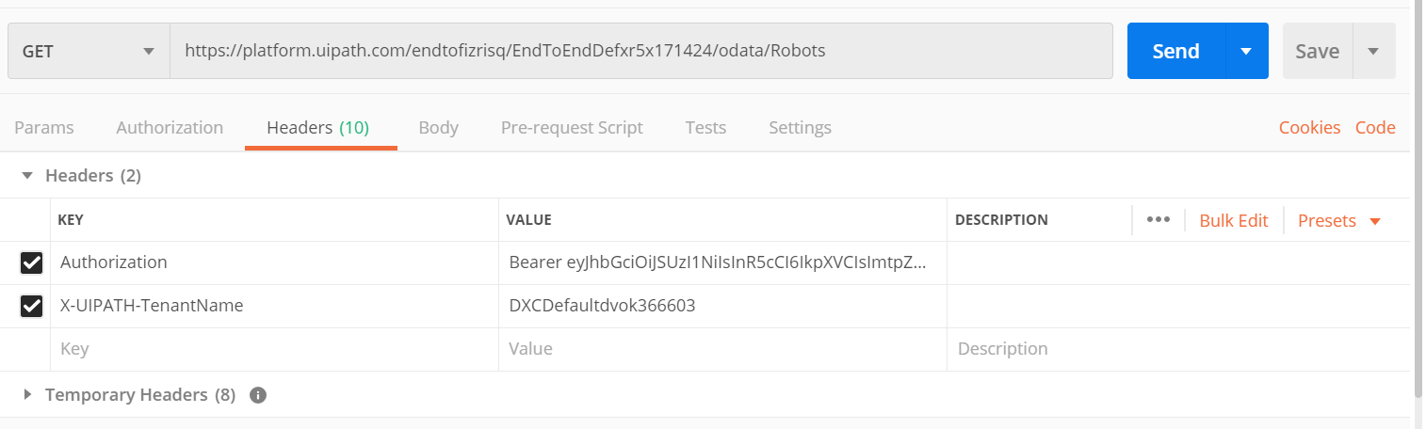

Response:

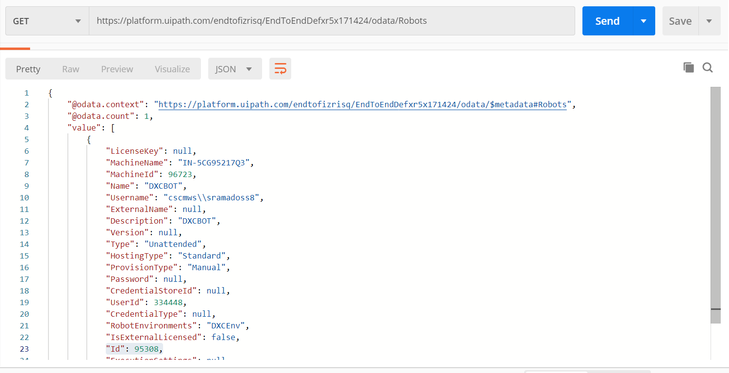

**4.Trigger Start Job From Api**

End Point(Post request)-

https://platform.uipath.com/endtofizrisq/EndToEndDefxr5x171424/odata/Jobs/UiPath.Server.Configuration.OData.StartJobs

Authorization Tab: No Auth

Headers-

X-UIPATH-TenantName - Value(Tenant Logical Name from your Orchestrator)

Authorization - Bearer <<access_token noted in the last step>>

Body: Raw, Jason

{

"startInfo" :{

"ReleaseKey" : "<<Release Key from Step 2>>",

"Strategy" : "Specific",

"RobotIds" : "<<Robot Id noted from Step 3>>",

"NoOfRobots" : 0

}

}

**Output -201(Success)-** Job should triggered in that machine

**Sample screenshot to trigger job in Orchestrator through API:**

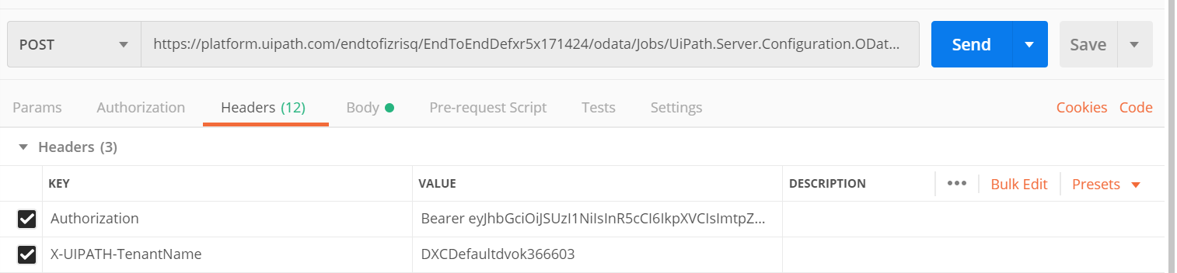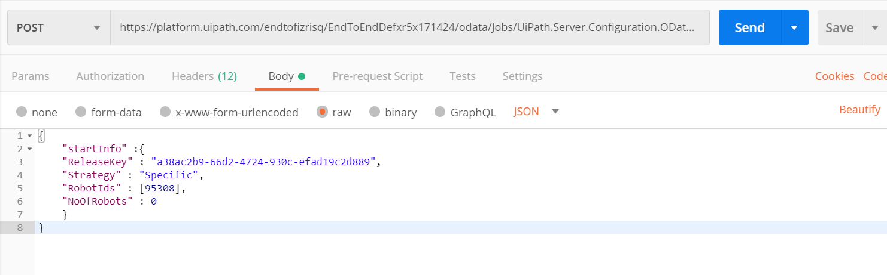

Response : Job should be triggered in that machine

